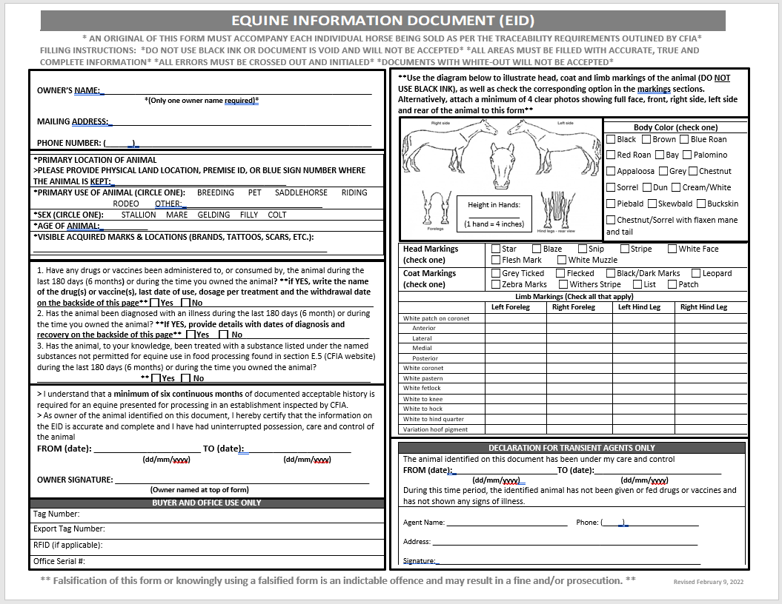
5
6
e
10
f
d
c
a
b
12
11
9
8
7
4
2
3
1
An original of this form must accompany each individual horse being sold as per the traceability requirements outlined by CFIA
- Do not use black ink or document is void and will not be accepted
- All areas must be filled with accurate, true and complete information
- All errors must be crossed out and initialed
- Documents with white-out will not be accepted

- Owner’s Name: Must be the owner’s name. If there is more than one owner, please provide ONLY ONE name
- Proof of sale must be provided if the horse is branded with a brand registered to someone other than the owner showing on the EID
- Address: Must provide full mailing address including postal code
- Phone Number: Phone number provided must be active and belong to the named owner of the horse
- Primary Location of Animal: Must be full rural address, legal land description or Alberta blue sign location. DO NOT use mailing address
- Primary Use of Animal: Check one options. If none of the options fit the horse’s primary use, check “Other” and provide an alternate description
- Age of Animal: Provide the approximate age of the horse. If not known, UNKNOWN (UNK) will be accepted
- Visible Acquired Marks & Locations: Marks that the horse was not born with or has acquired throughout their life.
- If checked yes, please list: date, dose, administration type (ex. Pills, liquid, cream) and withdrawal period listed on the treatment given on the back side of the EID
- If marked, yes, please provide details of diagnosis and recovery on back side of EID
- For reference, a list of prohibited drugs can be found at https://inspection.canada.ca/food-safety-for-industry/archived-food-guidance/meat-and-poultry-products/manual-of-procedures/chapter-17/annex-e/eng/1370023131206/1370023203607
- Dates MUST be accurate and should read DD/MM/YYYY (ex. 09/02/2022 for February 09, 2022). An alternative is to write out the full date using the month by name (ex. February 09, 2022)
Dates must show a minimum of 180 days (6 months) of continuous ownership
** By signing the owner declaration, you are confirming that all information you have provided on the EID is accurate and true. Falsification of the EID or knowingly using a falsified form is an indictable offense and may result in a fine and/or prosecution. **
- Color and Markings Please refer to the following link for a more detailed reference: https://www.inspection.gc.ca/animal-health/terrestrial-animals/diseases/accredited-veterinarian-s-manual/chapter-2/eng/1345231064142/1345231128550?chap=2

Please illustrate head and coat and limb markings on the diagram (DO NOT USE BLACK INK)
  - Height to be recorded in hands; (1 hand = 4 inches)
  - Body Color: Check one. See list below for a description of the colors
Black: When black pigment is general throughout the coat, limbs, mane and tail, with no pattern factor present other than white markings.
Brown: When there is a mixture of black and brown pigment in the coat, with black limbs, mane and tail
Blue Roan: When the body color is black or black-brown, with a mixture of white hair, which gives a blue tinge to the coat. On the limbs from the knees and hocks down, the black hair usually predominates.
Red Roan: When the body color is a chestnut or chestnut-grey with a mixture of white hair, which gives a red tinge to the coat.
Bay: Bay varies considerably in shade from dull red approaching brown, to a yellowish color approaching chestnut, but it can be distinguished from the chestnut by the fact that the bay has a black mane and tail and almost invariably has black on the limbs and tips of the ears.
Palomino: The body coat is a newly-minted gold coin color (lighter or darker shades are permissible) with a white mane and tail
Appaloosa: Body color is grey, covered with a mosaic of black or brown spots.
Grey: When the body coat is a varying mosaic of black and white hair with black skin. With advancing age, the coat grows lighter in color. The flea-bitten grey may contain three colors or the two basic colors and should be so described. A pure white is exceptional.
Chestnut: This color consists of yellow-colored hair in different degrees of intensity, which may be noted if thought desirable. A “true” chestnut has a chestnut mane and tail which may be lighter or darker than the body color. Lighter colored chestnut may have flaxen mane and tail. The sorrel color must be reported under that name.
Sorrel: When the body consists of a copper-red coat lacking in any black. Typically, the mane and tail are red.
Dun: When the body has a color dilution that lightens the coat with the head, lower legs, mane and tail remaining undiluted. A dark dorsal stripe is prominent down the spine.
Cream/White: The body coat is of a cream color, with non-pigmented skin. The iris is deficient in pigment and is often devoid of it, giving the eye a pinkish or bluish appearance.
Piebald: The body coat consists of large, irregular patches of black and white. The line of demarcation between the two colors is generally well defined.
Skewbald: The body consists of large irregular patches of white and of any definite color except black. The line of demarcation between the colors is generally well defined.
Buckskin: When the body consists of certain shades of tanned deerskin, being a tan or gold colored coat with black points on the legs, mane, and tail
Chestnut/Sorrel with Flaxen Mane and Tail: When the body consists of chestnut or sorrel in color and the mane and tail are golden blonde in color, creating flaxen.

  - Head Markings: See below for an illustration guide for diagram

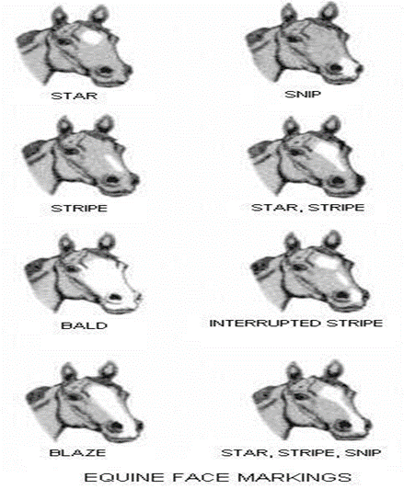

  - Coat Markings: All white markings on the limbs must be accurately defined and the upper limit precisely stated with reference to points of the anatomy, ex. white to mid-pastern, white to upper third of cannon. The use of such terms as "sock" or "stocking" are not acceptable. The exact location must be specified, for example:
White coronet; white pastern; white fetlock; white to knee; white to hock; white to hind quarter;
White patch on coronet (anterior, lateral, medial, posterior); White ring around limb: does not extend down to the coronet. The presence of colored spots in white marks should be recorded. Black spots in a white coronet are referred to as ermine marks.

  - Limb Markings: See below for an illustration guide for diagram

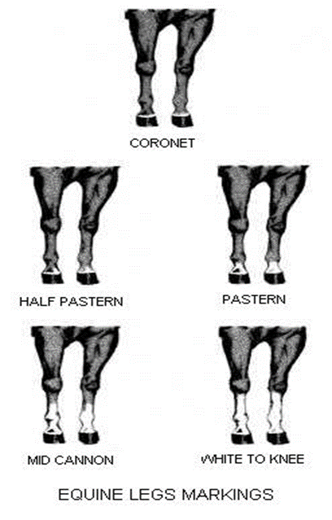

  - Transient Agent Declaration (FOR TRANSIENT AGENTS ONLY!!)

- This section is to be filled in by an individual who purchased the horse and will only hold it for a small time. This is not the owner nor should the possession dates reflect more than 179 days. If this occurs, an additional EID showing the Transient Agent as the owner will be required.
- Dates of ownership and care between the owner and the transient agent must correlate and show continuous care of the horse with no gap.
- Take extra care when writing dates, ensuring they are correct. The preferred format for the written dates is dd/mm/yyyy, but the alternate of writing out the full date, using the name of the month (ex. February 09, 2022) is acceptable.

